Appendix A

Nurse Support Program II FY 2017 – Competitive Institutional Grants
Lead Applicant Institution/Organization: ___________________________________________________

Title of Project: _________________________________________________________________

Partnership Members: _________________________________________________________________
Type of Competitive Grant Initiative: (Check (√ ) ONE of the following initiatives.)

 | 1. Initiative to Increase Nursing Pre-licensure enrollments and graduates |  |  | 3.Initiative to Increase the Number of Doctorally prepared Nursing Faculty
 | 2.Initiative to Advance the Education of Students and RNs to BSN, MSN, and Doctoral Level |  |  | 4.Initiative to Build Collaborations between Education and Practice that Develop New Models that Promote a Patient Centered Continuum of Care
 |  |  |  | 5.Initiative to Increase Statewide Resources

Projected Outcomes: (Identify below the number of additional outcomes expected from funding)

Final Outcomes | Projected Increase ( # of Additional) Describe Degrees/Results
Nursing Pre-Licensure Graduates
Nursing Higher Degrees Completed
Nursing Faculty at Doctoral Level
Collaborative or Statewide Results

Funds Requested: _____________ Value of Match Provided (Funds, In-Kind, etc.):__________________

Project Duration:_________________Project Director(s): _____________________________________

E-mail address: _____________________________ Phone number: _____________________________

Fax Number: _______________________________

Mailing Address: ____________________________________________________________________
____________________________________________________________________
Grants Office Contact, Name & Title (post award): ____________________________________________________________________________________

E-mail address: _____________________________ Phone number: _____________________________

Finance or Business Office Contact, Name & Title: __________________________________________

E-mail address: _____________________________ Phone number: _____________________________

Certification by Authorizing Official:
Name: _______________________________ Title: __________________________________________
Signature: ____________________________________________________________________________

Mandatory Data Table for all Proposals and all Future Interim Annual and Final Reports

FACULTY for current AY ( 2015-2016) | Equivalents (Total FTEs)
 | FT | PT | Total Number
Nursing faculty with PhD in Nursing
Nursing Faculty with PhD - Other
Nursing Faculty with DNP
Nursing Faculty with EdD
Nursing faculty with MSN
Clinical nursing faculty with BSN
Clinical nursing faculty with MS

How many vacant faculty positions does your program have?
 | Full-Time | Part-Time
Number of Vacant Faculty Positions

If vacancies, what was the primary cause?
__ Budget constraints
__ Lack of qualified applicants
_ _ Other (Specify):

Certified Nurse Educators | # with CNE | % of FT Faculty
Number of FT Faculty with NLN CNE credential

Describe the limitations on the capacity of your program during the current academic year
- Faculty recruitment. Specify areas of expertise and/or primary barriers:
- Availability of clinical placements. Specify area(s) of shortage and current clinical sites:
- other: Describe (e .g. institutional, capacity, demand, student recruitment, etc. :

Academic Year/Session for Indicated Program- Describe Program Type

Program Capacity (new students only)
Number of qualified applicants
Qualified but not admitted
Admitted who registered
Graduation Rate
Retention Rate

# Graduates per academic year (as appropriate)

Graduates | ADN | BSN | Master Entry |  | RN-BSN |  | RN-MSN | MS | DNP | PhD

Demographics - Students/Faculty

Number from Underrepresented Groups in Nursing (ethnic/racial minorities, gender, age) for both Students and Faculty

Underrepresented Groups in Nursing | Ethnic/Racial Minority
 | % Asian | % Black/ African American | %  Latino/ Hispanic | %  Pacific Islanders and Native  Americans | % White | %  Mixed Race | %  Other | Total Number
Nursing faculty (FT)
Clinical or part-time faculty
Nursing students

Underrepresented Groups in Nursing | Ethnic/Racial Minority
 | % White | % Non-White | Total Number
Nursing faculty (Full Time)
Clinical or part-time faculty
Nursing students

Underrepresented Groups in Nursing | Gender
 | Female | Male | Total Number
Nursing faculty (FT)
Clinical or part-time faculty
Nursing students

Underrepresented Groups in Nursing | Age
 | Less than age 30 | Greater than age 60 | Total Number
Nursing faculty (FT)
Clinical or part-time faculty
Nursing students

Geographic Impact
In-State or Out of State | State of Residence
 | Maryland | Geographic Neighbors (VA,DE, DC, PA, West VA) | Other States | Total Number | Percent In State
Nursing faculty (FT)
Clinical or part-time faculty
Nursing students

SAMPLE BUDGET SUMMARY
Nurse Support Program II – Competitive Institutional Grants
Prepare each Annual Budget Request and Total Application Budget in Excel
Forms and Report Templates available at www.nursesupport.org
Lead Institution & Project Title: ________________________________________________________

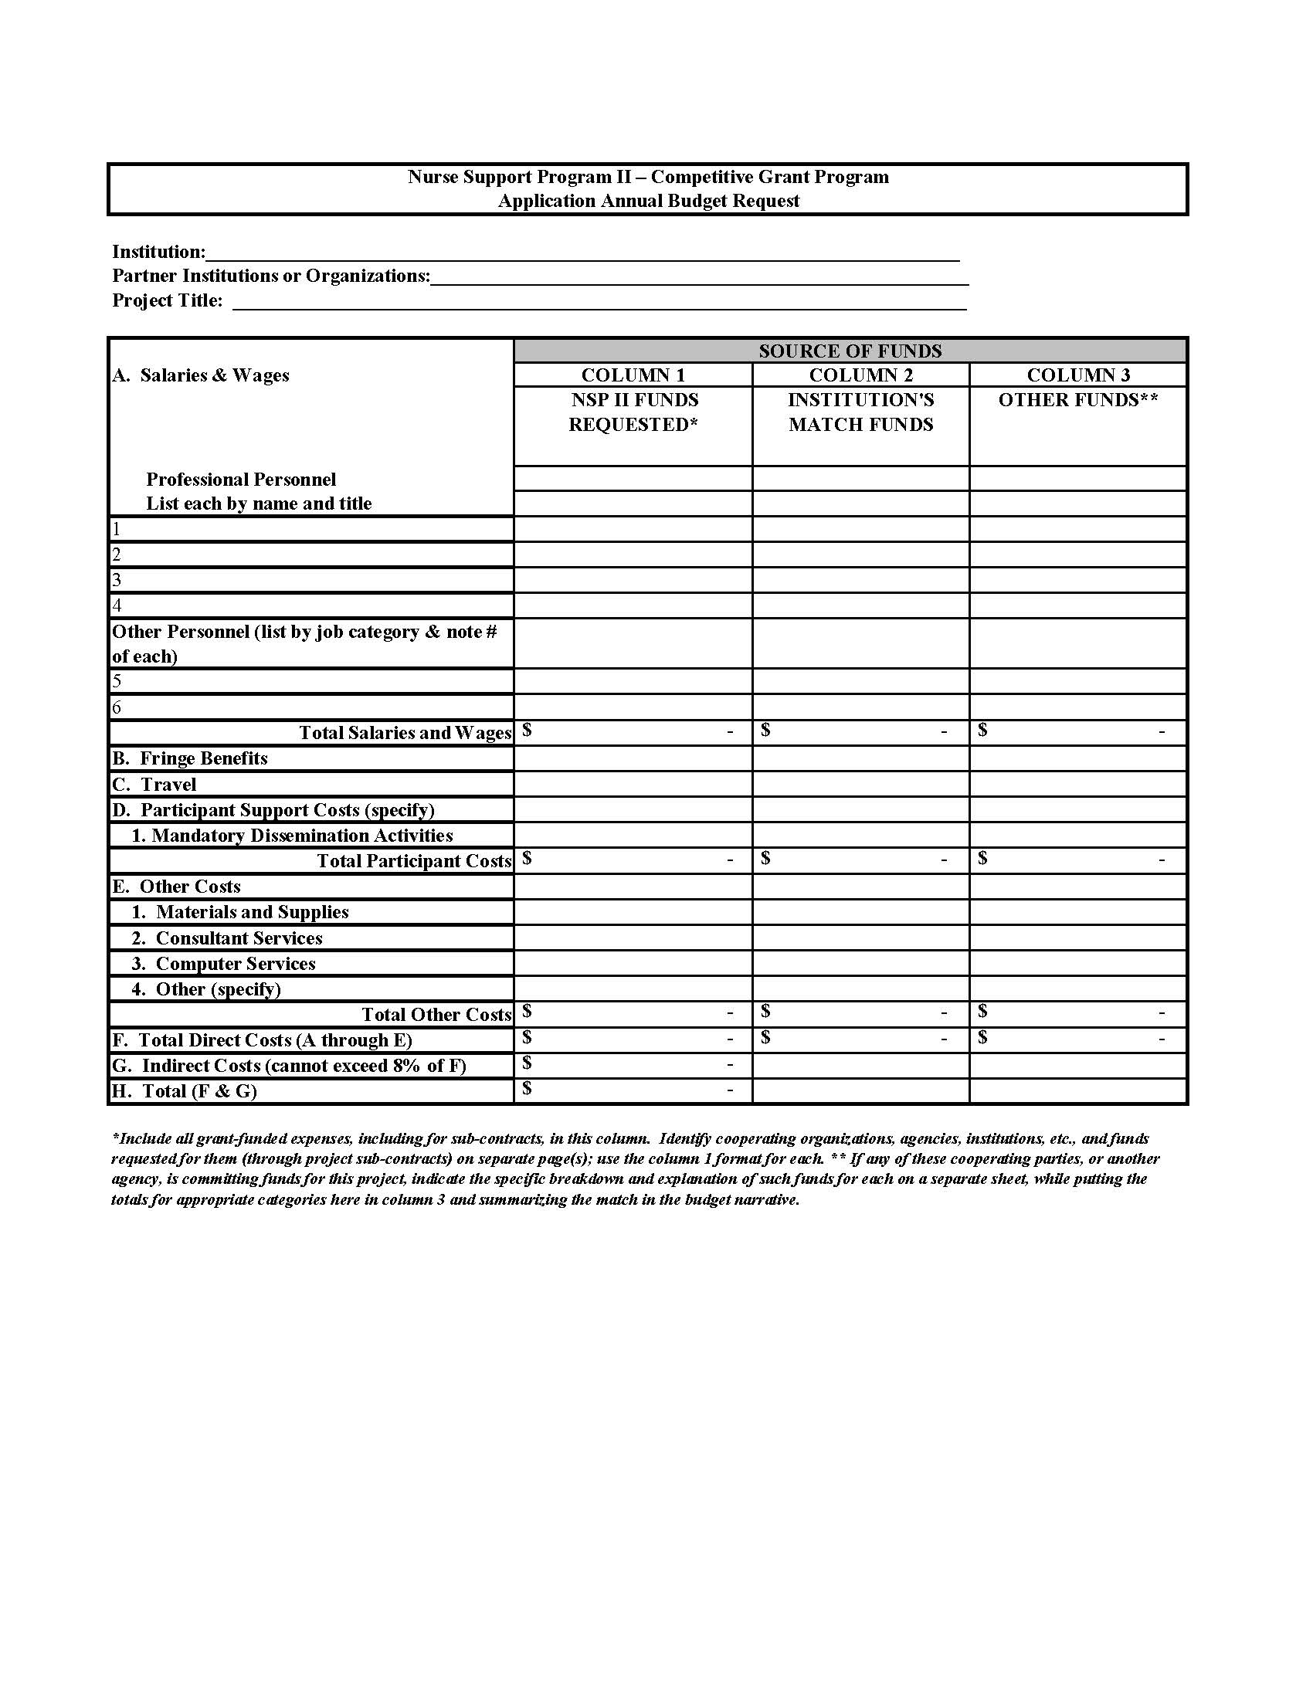

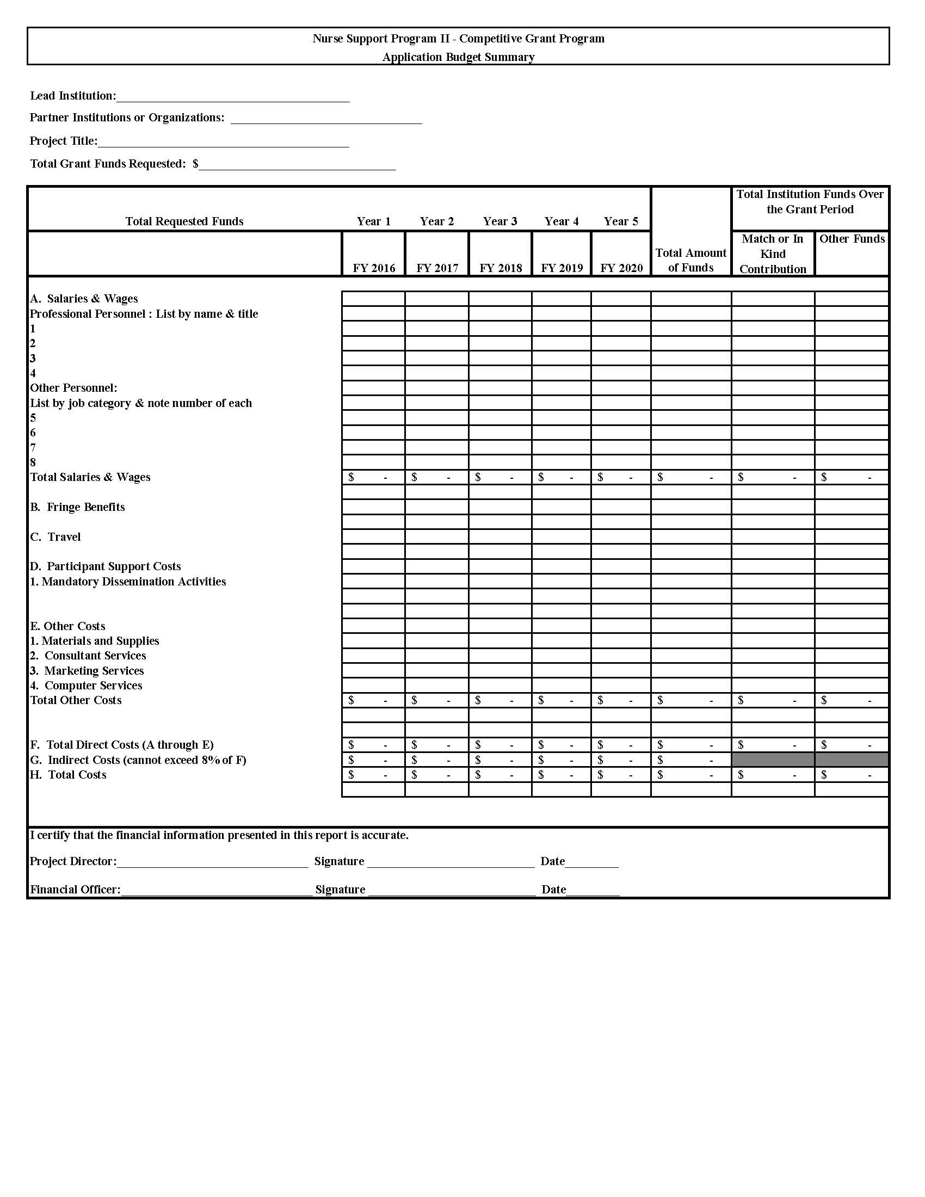
SAMPLE BUDGET NARRATIVE
Nurse Support Program II – Competitive Institutional Grants
Lead Institution: _______________________________________________________
Project Title: __________________________________________________________
(These partial examples are provided only to demonstrate the format requested for the budget narrative. Provide as many sheets of paper as needed to provide justification for each line of the budget summary, as outlined in the RFA.)

- Salaries & Wages
Professional Personnel:
  - Column 1: Dr. Jill Smith, the project director, will spend 10% of her time in project activities during the academic year. Maryland State University requests only the amount it will cost the university to pay an adjunct to replace Dr. Smith in one course. Request = $4,900

Column 2: The university will contribute the difference between the $4,900 requested and 10% of Dr. Smith’s 10-month annual salary as in-kind cost share valued at $3,100.
Match = $3,100

Other Personnel:
a. Administrative Assistant (1): Request = $12.00/hour x 5 hours/week x 78 weeks = $4,680
(Assistant’s time not included as an indirect cost; time is scheduled for grant work)
Column 2: Assistant’s fringe benefits contributed as match:
5 hrs/wk x 78 weeks x 33% benefits rate x $12/hr. = $1,560

B. Fringe Benefits
1. Fringe benefits for the project manager’s spring semester release time are calculated at 33%
Request = $12,250 x .335 = $4,103.75
C. Travel
Travel for project director to partner hospital for six management committee meetings
Request = $0.485 cents per mile x 10 trips x 60 miles/trip = $291

D. Participant Support Costs
1. Stipends:
2 faculty members develop on-line courses @ $2,500 each per course
Request = $2,500 x 2 faculty x 6 courses = $30,000

2. Mandatory Dissemination Activities- all grant funded activities, strategies, models and successful outcomes are to be available to nursing programs and clinical practice leaders across the state. The allowable costs per faculty member should be outlined in this budget line item and provide for regular attendance at statewide activities through organizations charged with meeting mutual IOM goals.

E. Other Costs
Other: Snacks for 2 faculty recruitment seminars $5x20=$100, printing costs $1200

ASSURANCES

The Applicant hereby affirms and certifies that it will comply with all applicable regulations, policies, guidelines, and requirements of the Health Services Cost Review Commission (HSCRC) and the State of Maryland as they relate to the application, acceptance, and use of Nurse Support Program II funds in this project. Also, the Applicant affirms and certifies that:

1. It possesses legal authority to apply for the grant; e.g., an official act of the applicant’s governing body has been duly adopted or passed, authorizing filing of the application, including all understandings and assurances contained therein and directing and authorizing the person identified as the official representative of the application and to provide such additional information as may be required.

- It will comply with Title VI of the Civil Rights Act of 1964 (42 U.S.C. 2000d) prohibiting employment discrimination where discriminatory employment practices will result in unequal treatment of persons who are or should be benefiting from the grant-aided activity.

- It will enter into formalized agreement(s) with the local hospitals in the area(s) of proposed service, as well as with other members of the collaborative, where applicable.

- It will expend funds to supplement new and/or existing programs and not use these funds to supplant non-grant funds.

- It will participate in any statewide needs assessment program or other evaluation program as required by the HSCRC.

- It will give the HSCRC, the Maryland Higher Education Commission as the Grant Administrator, and/or the Legislative Auditor, through any authorized representative, the right of access to, and the right to examine all records, books, papers, or documents related to the grant.

- It will comply with all requirements imposed by the HSCRC concerning special requirements of law and other administrative requirements.

Institution

Signature of Authorized Institutional Authority

____________________________________ ____________________________________
Name and Title, Printed Date

